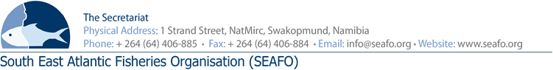

PROVISIONAL AGENDA FOR THE 12TH MEETING OF THE COMPLIANCE
COMMITTEE (CC) - 2019

CHAIRPERSON: Mr. Orlando Fachada (EU 2019-2020)
(Intersessional) / Mr. Kenro Iino (Japan) (Physical Meeting) VENUE: Strand Hotel, Swakopmund
VICE-CHAIR: Mr. Ryo Omori (Japan 2019-2020) DATE: 26 November 2019

Item | Agenda Item | Working Document
1 | Opening of meeting by Chairperson
2 | Appointment of rapporteur
3 | Adoption of Agenda and meeting arrangements | DOC/CC/00/2019  DOC/CC/01/2019  DOC/CC/02/2019
4 | Introduction of Delegations
5 | Introduction and admission of Observers
6 | Executive Secretary’s report on 2019 Compliance | DOC/CC/03/2019
7 | Annual Review of the “SYSTEM” | DOC/CC/04/2019
8 | Consideration of the Provisional SEAFO’s IUU Vessel List | DOC/CC/05/2019
9 | Recommendations on Additional Measures of Compliance
10 | Any other matters | DOC/CC/06/2019  DOC/CC/07/2019
11 | Venue & date of next meeting
12 | Adoption of the 2019 Compliance Committee Report
13 | Closure of meeting

Circulation Date: 26 October 2019

